**ASSIGNMENT-1**  **THE CASE OF 50 STARTUPS**

|  |  |
| --- | --- |
|  |  |
| **Student Name** | **Sarveshwaran.G** |
| **Student Roll Number** | **312319205142** |
| **Maximum Marks** | **2 Marks** |

**About the 50 startups dataset**

This particular dataset holds data from 50 startups in New York, California, and Florida. The features in this dataset are R&D spending, Administration Spending, Marketing Spending, and location features, while the target variable is: Profit.

**QUESTION-1:**

**R&D spending: The amount which startups are spending on Research and development.**

**Solution:**

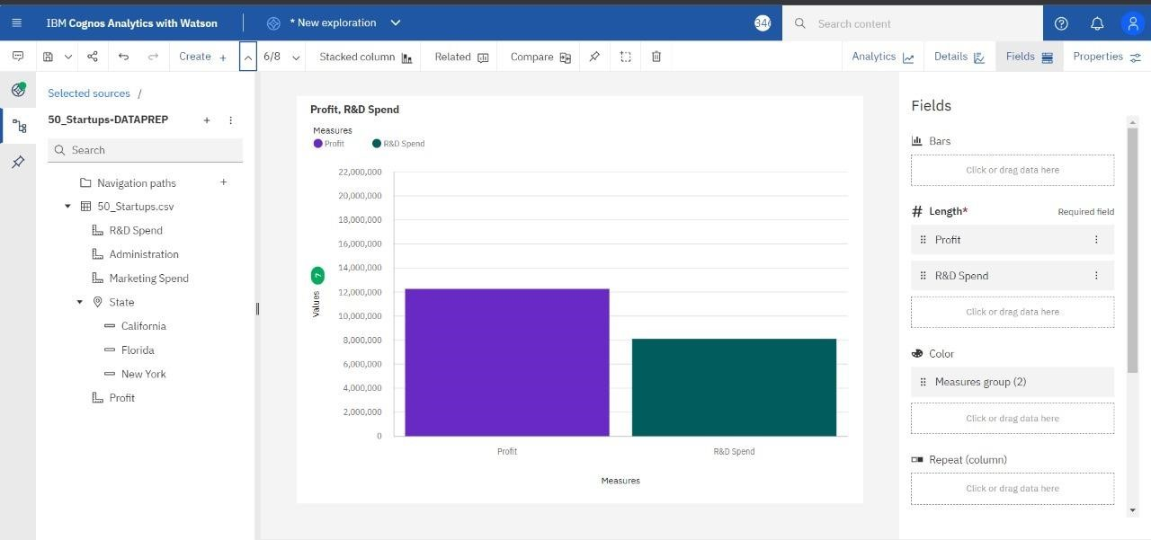

**QUESTION-2:**

**Administration spending: The amount which startups are spending on the Admin panel.**

**Solution:**

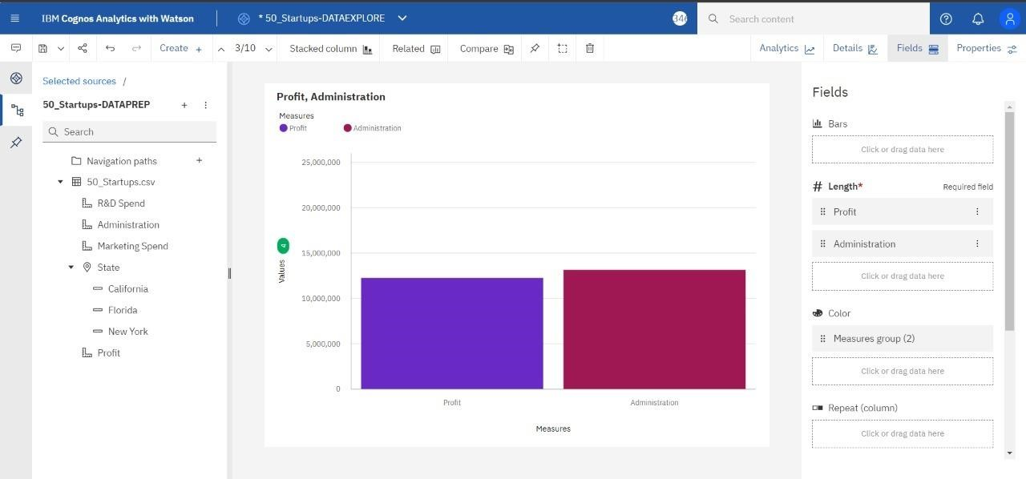

**QUESTION-3:**

**Marketing spending: The amount which startups are spending on marketing strategies.**

**Solution:**

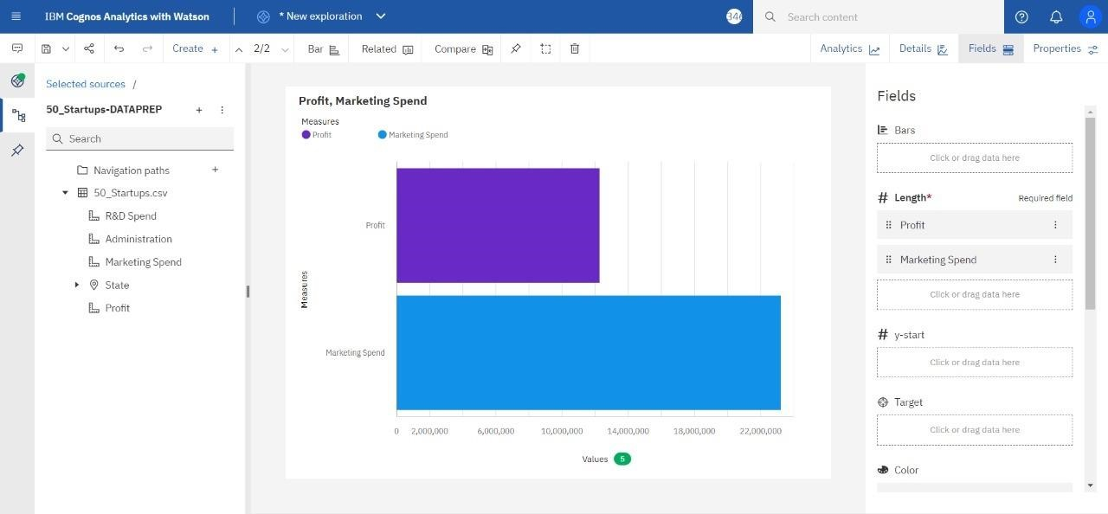

**QUESTION-4:**

**State: To which state that particular startup belongs.**

**Solution:**

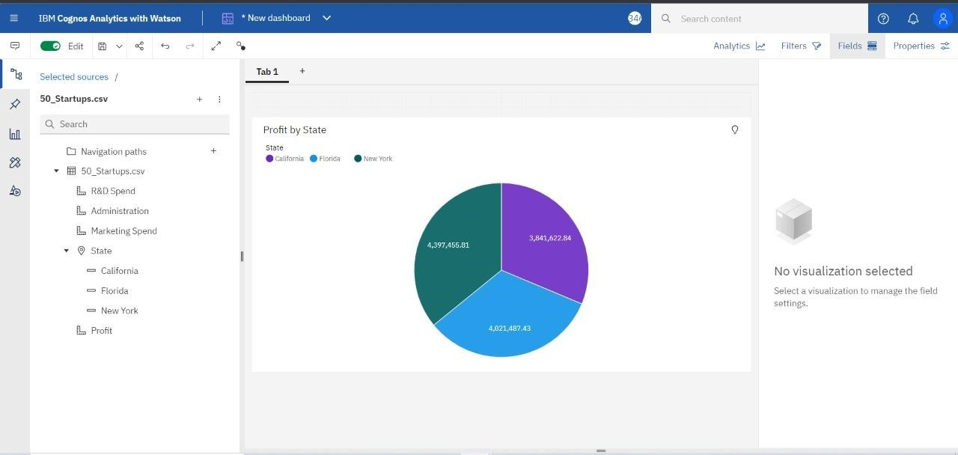

**QUESTION-5:**

**Profit: How much profit that particular startup is making.**

**Solution:**

